BCIS 5110.012 Programming Languages for Business Analytics
Fall 2024
Final Report

Cleaning and Analyzing the Data of Superstore Sales

Team Name: Oops, All Bugs
Team members
Ananya Sureshbabu
Harica Sakamuri
Jagadeesh Reddy Madana
Tharun Reddy Mannem

Group Members and Contribution to the Project and Report
This section outlines the contributions of each group member to the project, including the development of the Python code, analysis, report writing, and any additional tasks.
Group Member | Contributions
Ananya Sureshbabu | Report Write-Up Part:  - Summary of the project, project motivation, and dataset Description.  - Detailed data transformation and Imputations.  - Analysis for the first 5 questions.  - Findings, Implications/ Recommendations, and conclusions from the analysis.  Python Coding Part:  - Data description, transformation, and cleaning.  - Imputation for 7 columns and analysis for questions 1-5.
Tharun Reddy Mannem | Python Coding Part:  - Analysis of the remaining questions (6 and onwards) in Python.  - Explored the dataset further and discovered additional insights.  - Imputations for 5 columns
Harica Sakamuri | - Ensured the report was professionally formatted.  - Incorporated the right visualizations and interpretation of the data.  - Collaborated with Jagadeesh to present the findings clearly and effectively.
Jagadeesh Reddy Madana | - Worked alongside Harica to structure the report and ensure its clarity.  - Helped transform the analysis into a polished, visually engaging, and well-organized final report.

Teamwork and collaboration were key, allowing the group to effectively divide tasks across data cleaning, analysis, and reporting. This approach led to a thorough and insightful analysis of the Superstore sales data.

- Executive Summary:
This project examines the "Superstore Sales" dataset to gain insights into the sales performance and customer behavior of a large retail superstore. The primary aim is to identify trends in overall sales over different time periods, evaluate revenue generated by various product categories, and analyze regional sales differences. By focusing on these factors, the analysis provides actionable insights for better inventory management and effective marketing strategies. The results are intended to support store management in making informed decisions and enhancing customer satisfaction, while also laying the groundwork for future studies on sales improvement.
- Project Motivation/Background:
The "Superstore Sales" dataset was selected because it provides detailed information about retail sales and customer behavior in a competitive environment. This dataset enables us to investigate different factors that affect sales performance, making it a valuable tool for gaining insights. By looking at trends in sales, product categories, and regional differences, we can discover ways to improve inventory management and marketing efforts. Additionally, the potential to boost customer satisfaction through better decision-making makes this analysis important. Overall, this dataset offers an exciting opportunity to understand retail operations and enhance business strategies.
- Dataset Description:
The "Superstore Sales" dataset encompasses sales transactions from a large retail superstore, providing insights into the store's performance across various parameters. The dataset contains 9,800 entries and 18 columns, below are the details of the columns with its data types:

S. No. | Column Name | Description | Data type
1 | Row_ID | Unique identifier for each entry. | int64
2 | Order_ID | Identifier for each order. | object
3 | Order_Date | Date when the order was placed. | object
4 | Ship_Date | Date when the order was shipped. | object
5 | Ship_Mode | Method of shipment (e.g., Standard, Express). | object
6 | Customer_ID | Identifier for each customer. | object
7 | Customer_Name | Name of the customer. | object
8 | Segment | Customer segment (e.g., Corporate, Home Office). | object
9 | Country | Geographic information - country. | object
10 | City | Geographic information - city. | object
11 | State | Geographic information - state. | object
12 | Postal_Code | Geographic information - postal code. | float64
13 | Region | Region of the store (e.g., East, West). | object
14 | Product_ID | Identifier for each product. | object
15 | Category | Product categorization. | object
16 | Sub_Category | Further product categorization. | object
17 | Product_Name | Name of the product. | object
18 | Sales | Total sales amount for the order. | float64

- Data transformation/Exploratory data analysis:
  - Checking for Duplicates:
First the Superstore Salas data set was imported by reading a CSV file using 'latin-1' encoding and store it in a Data Frame called ‘ss’ using the pandas library.
During the data validation process, the Data Frame ss was checked for duplicate entries. The analysis revealed that there were no duplicate rows present in the dataset. This outcome indicates that each entry is unique, ensuring data integrity and reliability for subsequent analyses. The absence of duplicates is a positive finding, suggesting that the data is well-prepared and suitable for further processing and insights in the project.
  - Converting Data Types:
As part of the data preparation process, the Order_Date and Ship_Date columns were converted in the Data Frame ss to the datetime64 data type. This conversion was achieved using the pd.to_datetime() function with the specified format of '%d/%m/%Y', which corresponds to the day, month, and year format present in the data.
The results of the conversion are as follows:
- Order_Date: Successfully converted with 9,800 non-null entries, indicating that all but a few records were correctly formatted as dates.
- Ship_Date: Successfully converted with 9,357 non-null entries, suggesting that there are some missing or improperly formatted dates in this column.
Significance: This conversion is crucial for enabling date-based analysis and operations, such as calculating delivery times or analyzing trends over time. The non-null counts indicate a high level of data integrity, although the presence of missing values in the Ship_Date column may require further investigation to ensure comprehensive analysis. Overall, these adjustments enhance the dataset's usability and prepare it for subsequent analytical tasks.
  - Creation of New Columns:
In the data preparation phase, we created a new column, Days_Difference, in the DataFrame ss to quantify the time taken between the order date and the ship date. This was calculated by subtracting the Order_Date from the Ship_Date, and the result was converted to represent the difference in days.
The results of this operation are as follows:
- Days_Difference: The new column contains 9,357 non-null entries, stored as float64 data type. This indicates that the calculation was successful for the majority of records, corresponding to the entries in the Ship_Date column.
Significance: The Days_Difference column is valuable for analyzing shipping efficiency and customer fulfillment times. By quantifying the time taken for orders to be shipped, we can identify trends, assess performance, and make data-driven decisions to improve logistics and customer satisfaction. The presence of non-null values reflects the effectiveness of the initial data cleaning and conversion steps, enabling more robust analysis in subsequent stages of the project.
  - Exploratory Analysis:
Data Overview:
Shape of the Dataset: The Data Frame ss contains 9,800 entries and 19 columns, indicating a robust dataset suitable for analysis.
Data Types and Non-Null Counts: The dataset includes a mix of data types:
- Integer: 1 column (Row_ID) with complete data.
- Object: 13 columns (Order_ID, Ship_Mode, Customer_ID, etc.), with some columns having missing values.
- Datetime: 2 columns (Order_Date, Ship_Date) successfully converted to datetime format.
- Float: 3 columns (Postal_Code, Sales, Days_Difference) with varying non-null counts.
Descriptive Statistics:
Summary Statistics for Numerical Columns:
The describe() method provided key statistical insights, including:
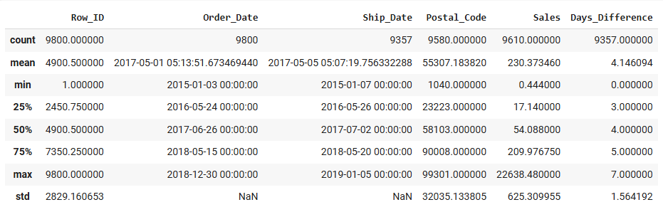
These statistics offer valuable context regarding the sales figures and the Days_Difference metrics, helping to identify trends and outliers.
Unique Value Counts for Categorical Columns:
The analysis of categorical columns revealed the number of unique entries for each attribute, as follows:
- A dictionary displaying the counts of unique values across various categorical columns, such as Order_ID, Ship_Mode, Customer_ID, and others.
Missing Values Analysis:
As part of our data quality assessment, the missing values analysis was conducted on the Data Frame ‘ss’. The key finding from this analysis is:
- Overall Percentage of Null Values: The dataset contains 5.03% null values.
Distribution Analysis:
In this section, a distribution analysis was conducted on key variables within the dataset, providing visual insights into sales performance, shipping methods, and customer segments. The findings are summarized below:
- Sales Distribution: The histogram of sales distribution reveals the frequency of different sales amounts.
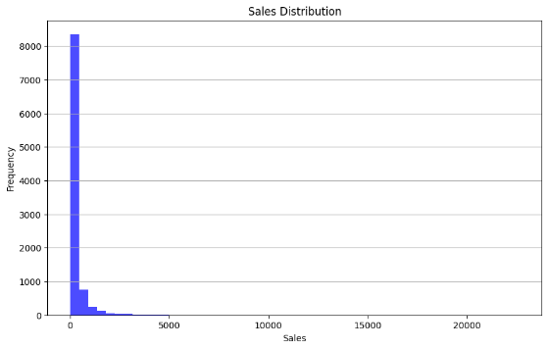
- Days Difference Distribution: The histogram for the Days Difference variable shows the frequency of shipping durations.
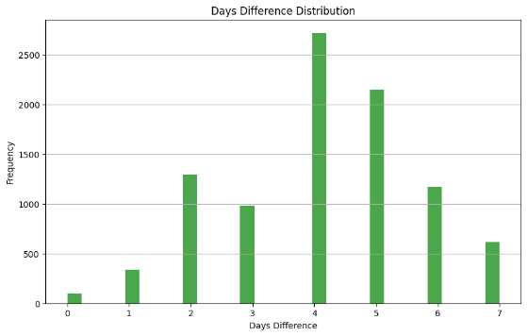
- Ship Mode Analysis: The bar chart depicting the distribution of ship modes indicates the frequency of each shipping method used.
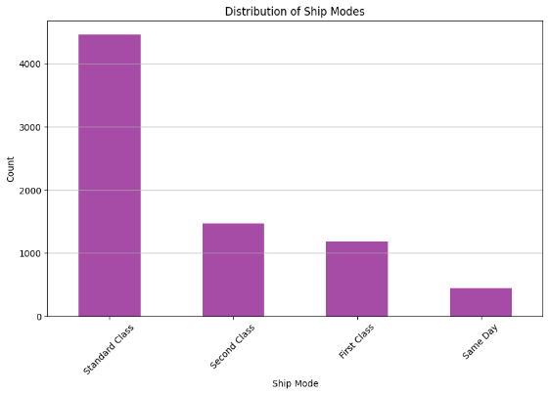
- Customer Segment Analysis: The distribution of customer segments illustrates the counts of different segments served.
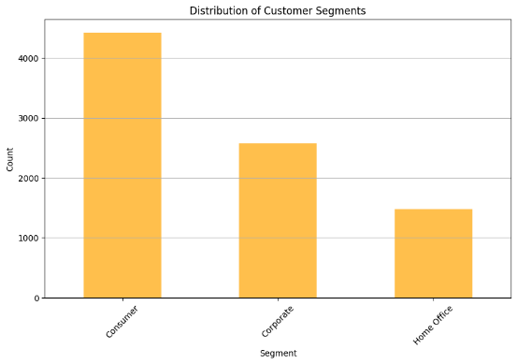
  - Imputation of Missing Values:
Imputation of Ship_Date and Day_Difference columns:
In this phase of the data cleaning process, imputing missing values in the Ship_Date and Days_Difference columns of the Data Frame ‘ss’. The following steps were taken and results achieved:
Steps Taken:
- Calculate Days Difference: We computed the Days_Difference as the difference between Ship_Date and Order_Date, filling any missing values with the mean of the Days_Difference column.
- Convert Data Type: The Days_Difference column was converted to an integer type to ensure consistency in data representation.
- Average Days by Ship Mode: We calculated the average shipping days for each Ship_Mode to aid in imputing missing Ship_Date values.
- Define Imputation Function: A function was created to determine Ship_Date based on Ship_Mode and existing Ship_Date. For modes with missing dates, the function applies logic to calculate an estimated Ship_Date based on average delivery times:
  - Same Day: Matches the Order_Date.
  - First Class: Adds average days for First Class shipping.
  - Standard Class: Adds average days for Standard Class shipping.
  - Second Class: Adds average days for Second Class shipping.
- Apply Imputation: The function was applied across the Data Frame to fill in missing Ship_Date values.
Results:
- After the imputation process, the Ship_Date column now contains 9,800 non-null entries, indicating that all previously missing values have been successfully filled.
- The Days_Difference column also reflects 9,800 non-null entries, enhancing its usability for analysis.
Imputation of Ship_Mode:
Imputing missing values in the Ship_Mode column based on the calculated Days_Difference. The process involved the following:
Steps Taken:
- Define Imputation Function: A function, impute_ship_mode, was created to assign a shipping mode based on the number of days taken for shipping:
  - 0 Days: Assigned to 'Same Day'.
  - 1-2 Days: Assigned to 'First Class'.
  - 3-5 Days: Assigned to 'Standard Class'.
  - More than 5 Days: Assigned to 'Second Class'.
- Apply Imputation: The function was applied to fill missing Ship_Mode values using the combine_first method, which prioritized existing values in Ship_Mode and supplemented them with the newly computed values based on Days_Difference.
- Display Updated DataFrame: The updated DataFrame was displayed, showing Row_ID, Order_ID, Ship_Mode, and Days_Difference for verification.
Results:
- After the imputation, the Ship_Mode column now contains 9,800 non-null entries, effectively eliminating any missing values in this column.
Imputation of Customer_Name:
In this step, we focused on addressing the missing values in the Customer_Name column of the Data Frame ‘ss’. The approach involved the following steps:
Steps Taken:
- Count Unique Customer_IDs: We first checked the number of unique Customer_ID values to understand the diversity of customers in the dataset.
- Calculate Most Common Customer Names: We grouped the dataset by Customer_ID and aggregated the most frequently occurring Customer_Name for each ID using the mode function. This method ensures that we fill in missing names with the most representative value based on existing data.
- Update Customer_Name: We used the combine_first method to fill missing values in the Customer_Name column by mapping Customer_ID to the calculated mode names. This effectively updates the original DataFrame with the most common names where they were previously missing.
- Display Updated DataFrame: We displayed the updated DataFrame to verify changes and confirm the presence of new values in the Customer_Name column.
Results:
- After the imputation process, the Customer_Name column now contains 9,800 non-null entries, completely eliminating missing values in this column.
- The analysis shows that there are 793 unique customer names in the dataset.

Imputation of Segment:
In this step, we focused on addressing the missing values in the Segment column of the Data Frame ‘ss’. The following processes were undertaken:
Steps Taken:
- Identify Unique Segments: We first checked the unique values in the Segment column, which included three categories: 'Consumer', 'Corporate', 'Home Office', and a missing value (NaN).
- Calculate Most Common Segment: We grouped the data by Customer_Name and determined the most frequently occurring segment for each name using the mode function. This approach helps ensure that we fill in missing segment values with the most representative data based on existing associations.
- Update Segment Values: The most common segments were then mapped back to the original DataFrame. The combine_first method was utilized to replace missing values in the Segment column with the computed segments based on Customer_Name.
- Handle Remaining Missing Values: Any remaining NaN values in the Segment column were filled with a predefined value of 'Unknown' to ensure completeness.
- Display Updated DataFrame: We displayed the updated DataFrame to confirm that the Segment column now has no missing values.
Results:
- The Segment column now contains 9,800 non-null entries, effectively eliminating any missing values in this column.
Imputation of Country:
In this step, we addressed the missing values in the Country column of the Data Frame ‘ss’. Here are the details of the process:
Steps Taken:
- Identify Unique Values: Initially, we examined the unique values in the Country column, which included only one valid entry, 'United States', along with some missing values (NaN).
- Fill Missing Values: We filled all missing values in the Country column with 'United States'. This was appropriate given that the only existing country in the dataset was already identified as 'United States'.
- Verify Imputation: After the imputation, we checked the unique values in the Country column again to confirm that it now only contains 'United States', indicating successful filling of missing values.
Results:
- The Country column now consists entirely of 9,800 entries labeled as 'United States', eliminating all previously missing values.
Imputation of City Column
In this step, we addressed the missing values in the City column of the Data Frame ‘ss’. Here are the details of the process:
Steps Taken:
- Identify Unique Values: The City column had 503 unique cities, while the Postal_Code column had 600 unique postal codes. Missing values were present in the City column.
- Imputation Process: A mapping of cities to postal codes was created by grouping the ss_cities DataFrame (which contains City and Postal_Code) and counting the frequency of each combination. This was used to create a dictionary (city_dict) where each city is mapped to its corresponding postal codes and their frequencies. Missing city values were filled by looking up the corresponding city for each postal code in the city_dict. If a match was found, the City column was updated with the correct city name. For any remaining missing city values that could not be mapped using postal codes, the value was filled with the placeholder 'Unknown'.
- Verification: After imputation, the number of missing values in the City column was checked using ss['City'].isnull().sum(), which returned 0, confirming that all missing values were successfully filled.
Results:
- The City column now contains 9,800 non-null entries, with missing values successfully filled. Any unmatched postal codes were labeled as 'Unknown', ensuring that the column is complete and ready for analysis.
Imputation of State Column
In this step, we addressed the missing values in the State column of the Data Frame ‘ss’. Here are the details of the process:
Steps Taken:
- Identify Unique Values: There were 1762 missing values in the State column out of 9,800 rows. The Postal_Code column also had some missing values, which were used to help infer the missing State values.
- Imputation Process: A mapping of states to postal codes was created by grouping the ss_states DataFrame (which contains State and Postal_Code). This formed a dictionary (state_dict) where each state is associated with its corresponding postal codes. Missing State values were then filled by matching the Postal_Code to the corresponding state in the dictionary. For any remaining missing values that couldn't be matched, the State was set to 'Unknown'.
- Verification: After imputation, the number of missing values in the State column was checked using ss['State'].isnull().sum(), which confirmed that all missing values were filled.
Results:
- The State column now contains 9,800 non-null entries, with missing values successfully filled either by matching postal codes or setting unmatched entries to 'Unknown'.
Imputation of Postal_Code Column
In this step, we addressed the missing values in the Postal_Code column of the Data Frame ‘ss’. Here are the details of the process:
Steps Taken:
- Identify Unique Values: The Postal_Code column had 220 missing values out of 9,800 rows.
- Imputation Process: Missing Postal_Code values were filled based on the most frequent postal code within each combination of City, State, and Region. If the mode (most frequent value) was available, it was used to fill the missing entries. If no mode could be determined (i.e., no common value), the placeholder 'Unknown' was used. After imputation, rows with 'Unknown' values were removed from the DataFrame ‘ss’.
- Verification: After imputation, the number of missing values in the Postal_Code column was checked using ss['Postal_Code'].isnull().sum(), which returned 0, confirming successful imputation. A check for rows containing the placeholder 'Unknown' showed that 37 rows were affected, and these rows were subsequently dropped from the DataFrame. The updated DataFrame shape was verified to ensure the correct number of rows remained after dropping the 'Unknown' entries.
Results:
- The Postal_Code column now contains 9,763 non-null entries, with missing values successfully filled and placeholder values removed. The imputation process ensured that the column was complete and consistent.

Imputation of Product_Name:
In this step, we addressed the missing values in the Product_Name column of the Data Frame ‘ss’. Here are the details of the process:
Steps Taken:
- Identify Unique Values: There were 1,846 unique product names, with 1,858 unique Product_IDs, indicating some missing Product_Name values.
- Imputation Process: Missing values in Product_Name were filled based on Product_ID using forward fill (ffill) and backward fill (bfill) within each group.
- Verification: The imputation was verified by checking that no missing values remained (isnull().sum() == 0).
Results:
- The Product_Name column now contains 9,763 non-null entries, successfully filling all missing values and maintaining consistency within Product_ID groups.
Imputation of Sub_Category:
In this step, we addressed the missing values in the Sub_Category column of the Data Frame ‘ss’. Here are the details of the process:
Steps Taken:
- Identify Unique Values: The Sub_Category column had 122 missing values out of 9,763 rows.
- Imputation Process: Missing Sub_Category values were filled based on the most frequent Sub_Category within each combination of Product_ID and Category. If the mode (most frequent value) was available, it was used to fill the missing entries. If no mode could be determined, the placeholder 'Unknown' was used.
- Verification: After imputation, the number of missing values in the Sub_Category column was checked using ss['Sub_Category'].isnull().sum(), which returned 0, confirming successful imputation. A check for rows containing the placeholder 'Unknown' showed that 1 row was affected and filled with 'Unknown'.
Results:
- The Sub_Category column now contains 9,763 non-null entries, with missing values successfully filled. Only 1 entry remains with the placeholder 'Unknown', ensuring the column is mostly complete and consistent.
Imputation of Sales:
In this step, we addressed the missing values in the Sales column of the Data Frame ‘ss’. Here are the details of the process:
Steps Taken:
- Identify Unique Values: The Sales column had 190 missing values out of 9,763 rows.
- Imputation Process: Missing Sales values were filled based on the mean Sales value within each combination of Region, Category, and Sub_Category. The mean Sales for each group were computed and merged back into the DataFrame. The missing values in the Sales column were then filled with the corresponding group mean.
- Verification: After imputation, the number of missing values in the Sales column was checked using ss['Sales'].isnull().sum(), which returned 0, confirming that all missing values were filled.
Results:
- The Sales column now contains 9,763 non-null entries, with all missing values successfully filled using the mean sales values based on Region, Category, and Sub_Category. The column is complete and ready for analysis.

- Analysis: This analysis seeks to reveal trends and insights related to sales performance, customer behavior, and product popularity within the superstore framework. By exploring the dataset, we aim to uncover opportunities for optimizing inventory, refining marketing strategies, and boosting overall customer satisfaction using the following Research Questions:
  - What are the trends in total sales over time (monthly, quarterly, annually):
Objective: The objective of this analysis is to examine the trends in total sales over different time periods (monthly, quarterly, and annually) and calculate the growth rates for each period.
Steps Taken:
- Aggregating Total Sales: The total sales were aggregated by different time periods: monthly, quarterly, and annually.
- Visualization: The trends in total sales for each time period were visualized using line plots to better understand the sales performance over time.
- Growth Rate Calculation: The percentage change in total sales was calculated for each period (monthly, quarterly, and annually) to identify the growth rates.
Code Implementation:
- Monthly Sales: The total sales for each month were computed using the resample('M') function.
- Quarterly Sales: The total sales for each quarter were computed using the resample('Q') function.
- Annual Sales: The total sales for each year were computed using the resample('A') function.
- Growth Rates: The percentage change in sales was calculated using the .pct_change() function for monthly, quarterly, and annual periods.
Results:
- Monthly Sales Trends:
The monthly sales data reveals some significant fluctuations, with periods of high growth and sharp declines. Notable points include:
  - August 2016 showed a strong growth rate of 23.53%, while January 2017 experienced a sharp drop of -77.36%.
  - March 2018 witnessed an impressive growth rate of 197.02%, while December 2018 showed a decrease of -25.67%.
- Quarterly Sales Trends:
The quarterly sales data also showed substantial variability:
  - The first quarter of 2015 had steady growth, with the biggest quarterly jump seen in December 2017 (+72.43%).
  - March 2018 experienced a decrease of -47.35%, indicating potential seasonal or external factors influencing the sales.
- Annual Sales Trends:
The annual sales data showed the following key trends:
  - 2016 experienced a slight decline in sales with a growth rate of -4.89%.
  - 2017 and 2018 showed strong growth, with 2017 increasing by 29.88% and 2018 growing by 21.83%.
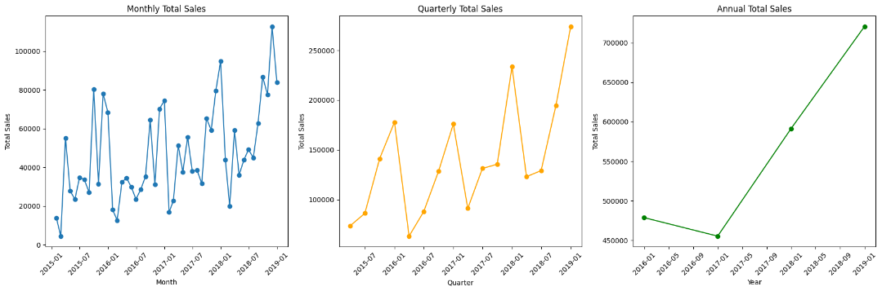
  - Which product categories generate the highest revenue, and how do they compare to one another:
Objective: The goal of this analysis was to identify which product categories generate the highest revenue and compare them in terms of their contribution to total sales.
Steps Taken:
- Revenue Aggregation: The total sales for each product category were calculated by grouping the data by Category and summing the Sales.
- Visualization: A bar chart was created to visualize the revenue generated by each product category, providing a clear comparison of the total sales per category.
- Revenue Contribution: The percentage of total sales generated by each category was calculated to understand the relative contribution of each category to overall revenue.
Code Implementation:
- Grouping by Category: The total sales for each category were summed using groupby('Category')['Sales'].sum().
- Visualization: The total revenue per category was plotted using a bar chart for easy comparison.
- Percentage Calculation: The percentage of total sales contributed by each category was calculated by dividing the sales of each category by the total sales.
Results:
- Revenue by Category:
The total revenue generated by each product category is as follows:
  - Technology: 36.39% of total sales
  - Furniture: 32.17% of total sales
  - Office Supplies: 31.44% of total sales
- Visualization: A bar chart was created to display the revenue distribution across the three categories. It showed that Technology leads in revenue generation, followed closely by Furniture and Office Supplies.
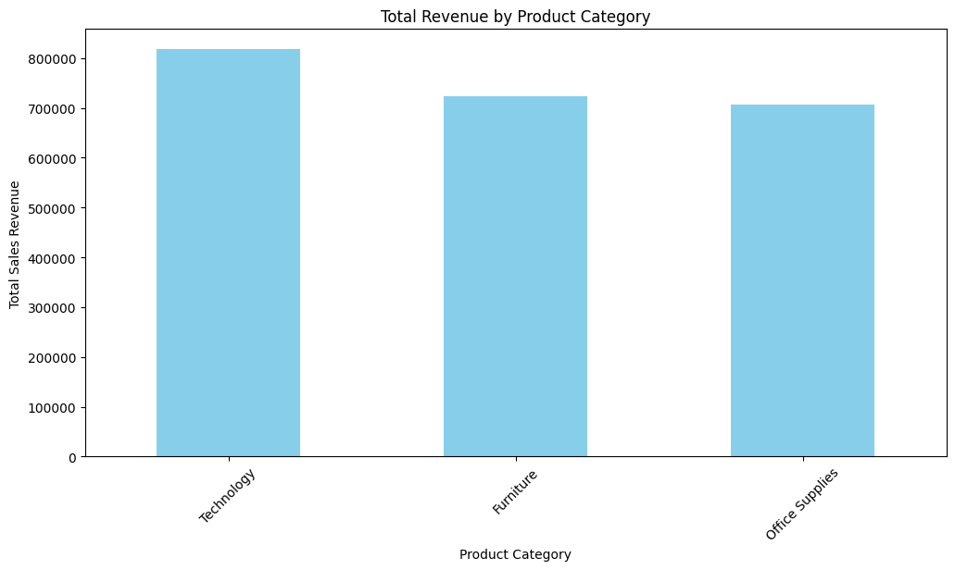
  - How do sales vary across different regions and cities, and what factors may influence these differences:
Objective: The goal of this analysis was to examine how sales vary across different regions and cities and identify potential factors influencing these variations, such as shipping times.
Steps Taken:
- Aggregate Sales by Region and City: The total sales for each region and city were calculated by grouping the data by Region and City and summing the Sales values.
- Visualization: Bar charts were created to visualize the total sales distribution across regions and the top 10 cities with the highest sales.
- Basic Comparison: Average sales by region and city were calculated to compare the performance of different regions and cities on a per-unit basis.
- Correlation Analysis: The relationship between shipping times (Days_Difference) and sales was explored by calculating the correlation between these variables.
Code Implementation:
- Grouping by Region: The total sales for each region were summed using groupby('Region')['Sales'].sum() to understand the total revenue generated by each region.
- Grouping by City: he total sales for each city were summed using groupby('City')['Sales'].sum(), and the top 10 cities were displayed for further analysis.
- Visualizations: The total sales by region were visualized using a bar chart to provide a clear comparison of sales across different regions. Similarly, the top 10 cities by sales were visualized with a bar chart.
- Average Sales by Region & City: The average sales for each region were calculated using groupby('Region')['Sales'].mean(), which provides insights into regional performance. Similarly, the average sales for each city were calculated using groupby('City')['Sales'].mean(), and the top 10 cities were displayed.
- Shipping Time Analysis: The average number of days taken to ship from the order received (Days_Difference) was calculated by grouping by Region. This helps in understanding shipping logistics across regions.
- Correlation with Sales: The correlation between Sales and other numerical columns (e.g., Days_Difference) was calculated using corr() to assess any relationships between sales and shipping times.
- Combining Sales and Shipping Time: A comparison was made between average sales and average shipping time (Days_Difference) by region to identify any potential relationships or trends.
Results:
- Sales by Region: The total sales by region are as follows:
  - West: $710,332.11
  - East: $662,179.25
  - Central: $488,880.10
  - South: $384,905.52
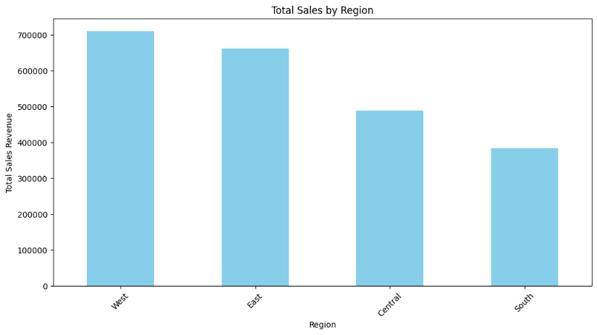
- Sales by City (Top 10): The top 10 cities contributing to total sales are:
  - New York City: $253,126.86
  - Los Angeles: $174,703.44
  - Seattle: $116,746.16
  - San Francisco: $110,168.81
  - Philadelphia: $109,443.71
  - Followed by cities like Houston, Chicago, and San Diego.
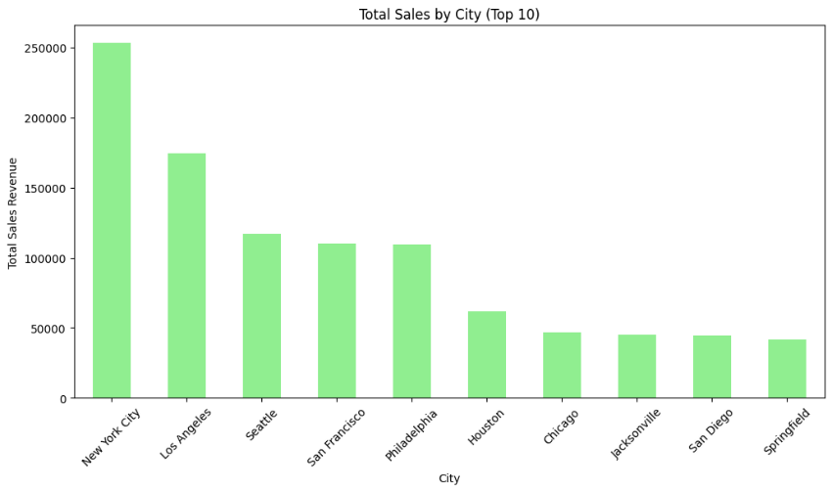
- Average Sales by Region:
  - Central: $215.94
  - East: $239.40
  - South: $241.47
  - West: $226.29
- Average Sales by City (Top 10):
  - Jamestown: $2,354.40
  - Cheyenne: $1,603.14
  - Norman: $1,287.45
  - Followed by Bellingham, Independence, and others.
- Shipping Times and Sales: Average Days Difference by Region
  - Central: 4.25 days
  - East: 4.10 days
  - South: 4.13 days
  - West: 4.11 days
- Correlation between Sales and Shipping Time: The correlation between Days_Difference (shipping time) and Sales is very low (-0.007), indicating almost no relationship between shipping times and sales.
  - What is the relationship between customer segments and their purchasing behavior (average order value, frequency of purchases):
Objective: The objective of this analysis is to examine the relationship between customer segments and their purchasing behavior, focusing on Average Order Value (AOV) and Purchase Frequency. Understanding these behaviors will help businesses tailor marketing strategies and identify the most profitable customer segments.
Steps Taken:
- Data Preparation: Ensured the dataset included relevant columns like Customer_ID, Segment, Sales, and Order_ID. Grouped data by Customer_ID to calculate total sales and the number of orders (purchase frequency) per customer.
- Calculate Key Metrics:
  - Average Order Value (AOV): Calculated by dividing total sales by the number of orders for each customer segment.
  - Purchase Frequency: The average number of orders placed per customer within each segment was calculated.
- Segmentation: Merged customer data with their respective segments (Consumer, Corporate, Home Office, Unknown) to analyze AOV and purchase frequency by segment.
- Visualization: Used bar charts to visualize the AOV and purchase frequency for each segment, allowing for a clear comparison of customer behavior.
Code Implementation:
- Total Sales and Order Count: Grouped by Customer_ID to calculate total sales and purchase count.
- Average Order Value (AOV): Calculated by dividing the total sales by the purchase count for each segment.
- Purchase Frequency: Aggregated the average number of purchases by segment.
- Visualization: Bar charts were generated to display AOV and purchase frequency for each customer segment.
Results:
- Average Order Value (AOV) by Segment:
The total revenue generated by each product category is as follows:
  - Consumer: $92,397 (highest AOV)
  - Corporate: $53,726
  - Home Office: $35,920 (lowest AOV)
  - Unknown: $549
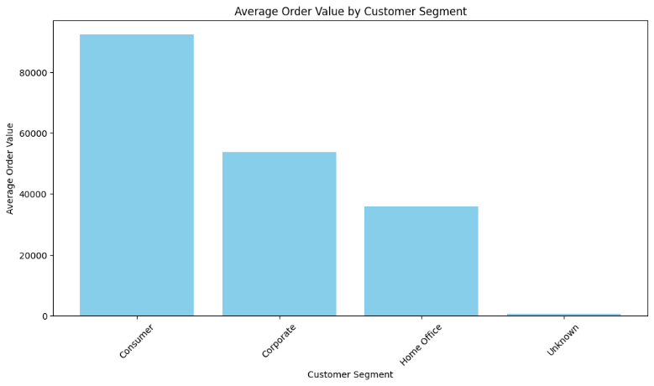
- Purchase Frequency by Segment
  - Consumer: 12.42 orders
  - Corporate: 12.49 orders
  - Home Office: 11.75 orders
  - Unknown: 11 orders
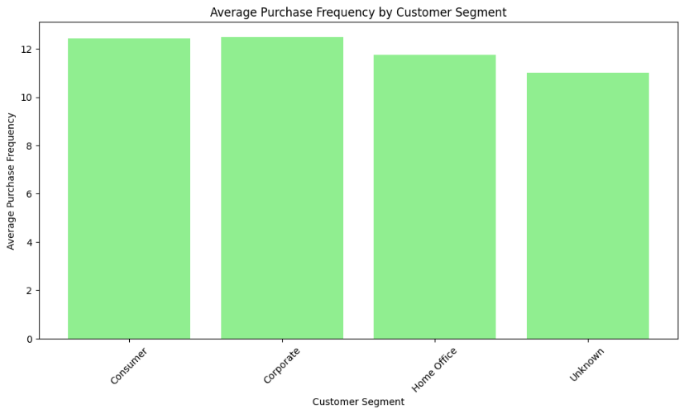
  - Are there specific times of the year when sales peak, and how can this information be used for inventory management:
Objective: The objective of this analysis is to identify specific times of the year when sales peak, and to use this information to improve inventory management. By understanding seasonal sales trends, businesses can optimize stock levels and coordinate with suppliers to meet demand during high-sales periods.
Steps Taken:
- Extract Time Features: New columns for Year and Month were created from the Order_Date to facilitate time-based analysis.
- Aggregate Sales Data: The sales data was grouped by year and month to calculate total sales for each month, allowing for the identification of sales trends over time.
- Identify Peak Sales: We identified the months with the highest sales each year to pinpoint peak sales periods.
- Inventory Management Recommendations: Based on the identified peak months, inventory management strategies were formulated to handle increased demand.
- Visualization: A line plot was created to visualize the monthly sales trends, with peaks highlighted for better clarity.
Code Implementation:
- Extracting Year and Month: Used dt.year and dt.month to extract the year and month from the Order_Date column.
- Aggregating Sales: Grouped by Year and Month to calculate the total sales for each period.
- Peak Sales Identification: Identified the months with the highest sales for each year using the idxmax() function.
- Visualization: Plotted monthly sales trends using a line plot, with peak sales points highlighted in red for each year.
Results:
- Peak Sales Months:
  - 2015: September (Sales = $80,400)
  - 2016: December (Sales = $74,502)
  - 2017: December (Sales = $94,807)
  - 2018: November (Sales = $112,707)
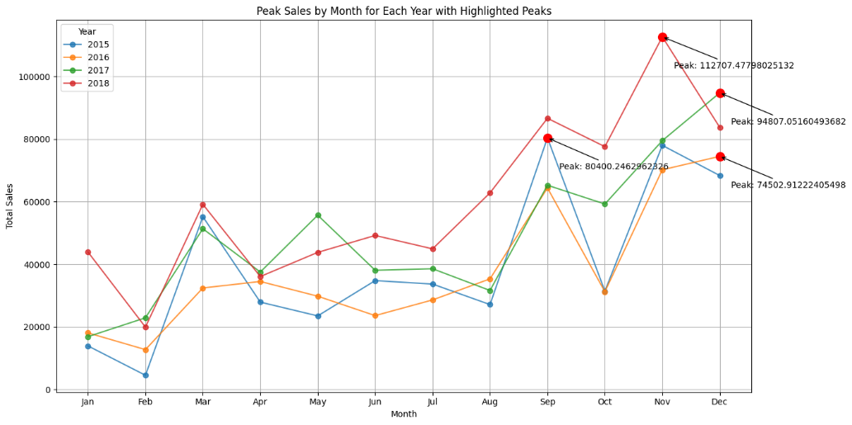
- Months Requiring High Inventory: Based on the identified peak sales months, it is recommended to increase stock levels during November and December (for 2017 and 2018), as these months saw the highest sales.
  - Which Shipping Modes Are Most Popular Among Different Customer Segments?
Objective: To identify the most and least popular shipping modes for each customer segment, uncover any trends in shipping preferences, and derive actionable insights for inventory, logistics, and marketing strategies.
Steps Taken:
- Group the Data by Customer Segment and Shipping Mode: The dataset was grouped by Segment and Ship_Mode to analyze total sales for each combination of customer segment and shipping mode.
- Aggregate Total Sales: The total sales for each shipping mode within each customer segment were computed using the sum() function. This provides a clear picture of how much revenue each shipping method generates within each segment.
- Normalize Sales Data: After aggregating the total sales, the values were normalized by converting them into percentages. This allows comparison across segments and shipping modes on a level playing field, irrespective of the actual sales volume in each segment.
- Visualize Data: A bar chart was plotted to visualize the normalized sales percentages for each shipping mode across customer segments. The bar chart is grouped by Segment, and each bar within a group represents a different shipping mode.
- Additional Analysis for Missing Data: In the case of missing values (e.g., unknown segments), appropriate handling was done by either imputing values or excluding those rows from analysis.
- Trend Analysis: The popularity of each shipping mode was examined for specific customer segments to determine any patterns or correlations. For example, we analysed if segments like Corporate preferred faster delivery or if Home Office favoured cheaper options.
Code Implementation:
- Group the data: The dataset is grouped by the Segment and Ship_Mode columns, and the sales are summed for each group using groupby(['Segment', 'Ship_Mode'])['Sales'].sum(). This gives the total sales for each combination of customer segment and shipping mode.
- Normalize Sales: The normalization of sales is done by applying the apply() method, where we divide the total sales for each shipping mode by the sum of sales for that particular segment. This gives us the percentage of sales contributed by each shipping mode within each segment.
- Bar Plot: A bar chart is created using plot(kind='bar'), where each bar represents the percentage sales for a shipping mode within a customer segment. The figsize=(10, 6) adjusts the size of the plot, and width=0.8 defines the bar width.
- Formatting: Titles, axis labels, and tick sizes are set for better readability. The legend is added to show the different shipping modes, and a grid is applied for easier comparison.
Results:
From the visualized bar chart and the data:
- Most Preferred Shipping Mode: Standard Class is the most popular across all customer segments, accounting for the largest portion of sales (around 56-59%).
- Least Preferred Shipping Mode: Same Day shipping has the lowest preference, contributing only 5% of sales, likely due to its high cost.
- Segment-Specific Insights: Consumer Segment: Primarily uses Standard Class (59.44%), with a smaller preference for Second Class (19.90%).
- Corporate Segment: Also favors Standard Class (56.63%) but shows slightly higher preference for Second Class (21.09%) compared to Consumer.
- Home Office Segment: Exhibits similar trends with Standard Class being most popular, but slightly higher preference for First Class (18.53%).
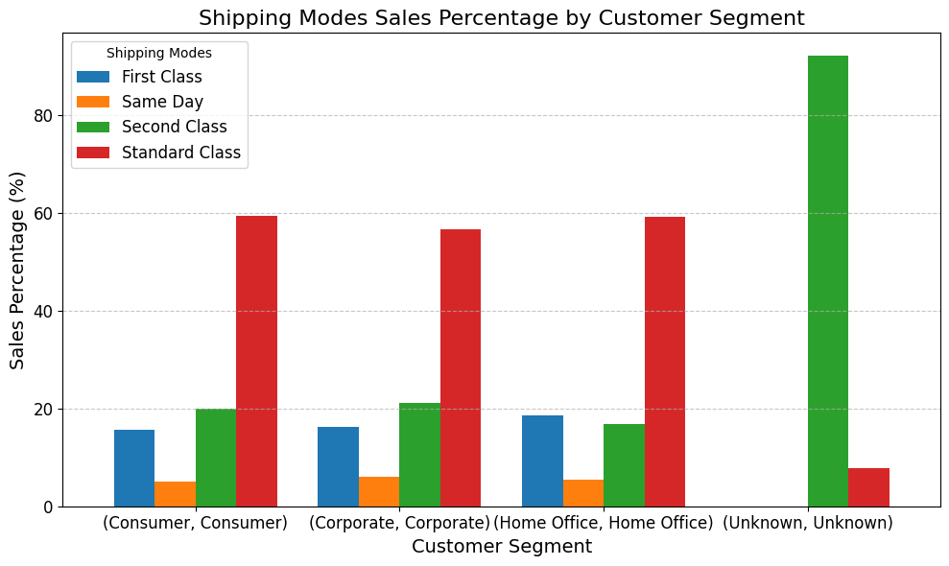
- Improve affordability for fast shipping; align modes with customer needsUnknown Segment: A notable anomaly in the Unknown segment, where Second Class dominates with 92.14%, and Standard Class only contributes to about 7.86% of sales. This could indicate missing or incomplete data for those orders.
  - Are Certain Days of the Week or Times of Day Associated with Higher Sales Volumes?
Objective: To identify patterns in sales volume by day of the week and determine if specific days or times of the day show higher customer activity, providing insights for promotional strategies and operational planning.
Steps Taken:
- Ensure 'Order_Date' is in Datetime Format: Converted the Order_Date column into datetime format to enable extraction of temporal information.
- Extract Day of the Week: Using the day_name() function, derived the day of the week from the Order_Date column for further analysis.
- Group Sales by Day of the Week: Sales were grouped by Day_of_Week and summed up to observe trends in sales volume across different days.
- Sort Days in Chronological Order: Reindexed the results using the sequence ['Monday', 'Tuesday', 'Wednesday', 'Thursday', 'Friday', 'Saturday', 'Sunday'] for clarity in visualization.
- Visualization of Weekly Sales: Created a bar chart to visually represent total sales by day of the week. The graph aids in spotting days with higher or lower sales activity.
- Analysis of Sales Trends: Identified patterns, highlighting days with notably high or low sales, and speculated potential reasons for these trends.
Code Implementation:
- Datetime Conversion: The pd.to_datetime() function standardizes the Order_Date column, enabling further manipulation.
- Day of the Week Extraction: Using the .dt.day_name() attribute, each date is mapped to its respective day of the week. This step creates a new column, Day_of_Week, to represent the weekday as a string.
- Grouping and Aggregation: The groupby() function is applied to the Day_of_Week column, summing up sales for each day. This aggregation helps calculate the total sales per weekday.
- Chronological Reordering: Days of the week are reordered into chronological sequence (Monday to Sunday) using the reindex() function. This ensures logical and intuitive representation in the results and visualizations.
- Visualization: A bar chart is plotted to visualize the distribution of total sales across the days of the week. Customizations such as labels, gridlines, and bar colors improve clarity and presentation.
Results:
- Day-wise Sales Distribution: The analysis reveals that sales volumes vary significantly across the days of the week. While Saturday and Tuesday exhibit the highest sales, Thursday and Friday lag behind.
- Key Observations:
- Saturday leads with the highest total sales, indicating heightened consumer activity during weekends.
- Thursday records the lowest sales, suggesting a potential gap in customer engagement or operational factors on this day.
- Patterns and Insights: Sales are relatively consistent from Monday to Wednesday, with a dip on Thursday and Friday before picking up on Saturday and Sunday. These patterns may reflect consumer preferences, lifestyle habits, or the effectiveness of weekday-specific marketing efforts.
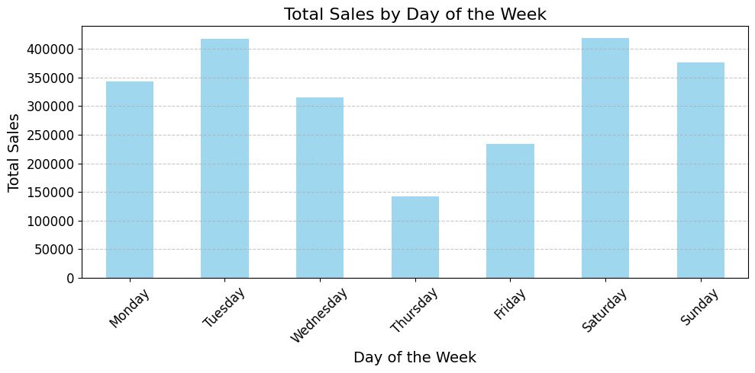
- Visual Representation: The bar chart provides a clear comparison of sales across the week, emphasizing the high sales on weekends and the noticeable decline on Thursdays and Fridays.

  - What are the top-selling product categories within each region, and how can these insights be used to optimize inventory in different locations?
Objective: To identify the top-selling product categories within each region and analyze how these insights can help optimize inventory distribution across different locations.
Steps Taken
- Data Aggregation: Grouped the dataset by Region and Category to compute the total sales for each combination.
- Pivot Table Creation: Converted the grouped data into a pivot table with Region as rows and Category as columns. This matrix structure helps compare sales across regions and categories at a glance.
- Visualization: Created a grouped bar chart to visualize the sales of each product category within different regions. This aids in identifying the top-performing categories visually.
- Analysis: Observed trends in the sales data to determine the leading product categories in each region.
Code Implementation:
- Grouping Data: The data is grouped by Region and Category using the groupby() method, and the Sales values are summed for each combination. This aggregation step allows us to calculate the total sales for every product category in each region.
- Pivot Table Creation: The pivot() function is used to restructure the data into a matrix format. In this format, Region is set as rows, Category as columns, and the aggregated sales values as the matrix content. This makes it easy to visualize and compare category-wise sales across different regions.
- Visualization:
- A grouped bar chart is plotted using the plot() function. Each region is represented as a cluster of bars, where each bar corresponds to a product category's sales.
- The chart uses distinct colours for each category to make comparisons straightforward.
- Customization: Labels, titles, and legends are added to the plot for clarity. The tight_layout() method ensures that the elements of the plot fit neatly within the figure.
- Displaying Results: Finally, the pivot table is displayed to provide the exact sales figures for further analysis.
Results:
- Pivot Table: The pivot table organizes sales data into a structured format where each region has its sales split across the categories: Furniture, Office Supplies, and Technology. This tabular representation provides precise figures for each combination, such as:
    - In the Central region, sales are:
      - Furniture: 157,710.96
      - Office Supplies: 164,479.94
      - Technology: 166,689.20
- Visualization: The bar chart visually highlights which product categories perform best in each region:
    - Technology consistently outperforms in most regions (Central, East, South).
    - Furniture has a slight edge over Technology in the West.
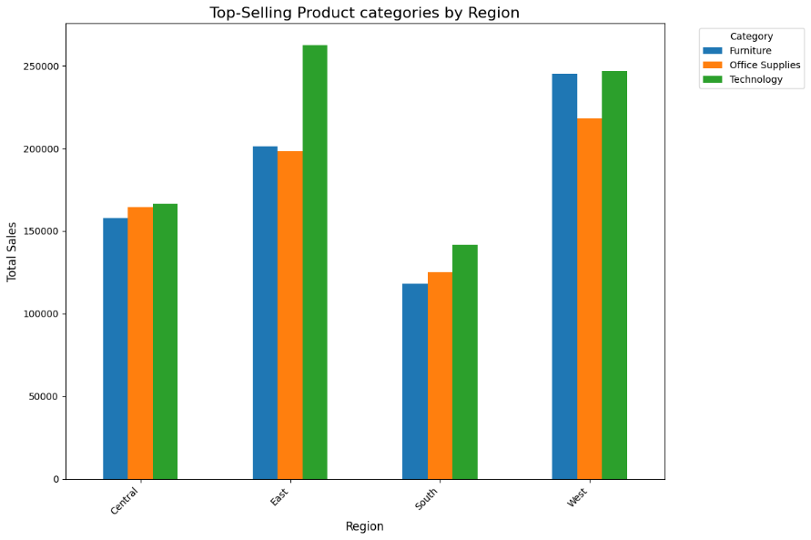
    - Office Supplies, while not the top-seller, shows steady performance across all regions.

  - Analysis of Customer Order Frequency?
Objective: The objective is to analyze customer order frequency and evaluate the percentage of repeat customers, their contribution to total sales, and the distribution of orders per customer.
Steps Taken
- Filter Customers with More than One Purchase: Identify customers who have placed more than one order by counting the frequency of orders for each Customer_ID.
- Calculate Percentage of Repeat Customers: Divide the count of repeat buyers by the total number of unique customers to determine the percentage of customers who made repeat purchases.
- Evaluate Sales Contributions: Calculate the total sales generated by repeat buyers and compare it with sales from one-time buyers.
- Visualize Sales Comparison: Create a bar chart to display the total sales from repeat buyers versus one-time buyers.
- Analyze Order Frequency Distribution: Plot a histogram to show the frequency distribution of orders per customer.
Code Implementation:
- Identifying Repeat Customers: value_counts() computes the number of orders for each Customer_ID. Filtering customers with more than one order isolates repeat buyers.
- Calculating Percentage: The formula len(repeat_buyers) / total_customers calculates the proportion of repeat customers, converted to a percentage.
- Sales Calculation: The sales contributions of repeat and one-time buyers are derived using filtering (isin() and ~isin() methods) on the dataset based on Customer_ID.
- Bar Chart Visualization: A bar chart is used to visually compare the sales contributions of repeat and one-time buyers, emphasizing the dominance of repeat buyers.
- Order Frequency Histogram: The histogram provides a visual representation of how many customers fall into each frequency category, revealing trends in purchasing behavior.
Results:
- Percentage of Repeat Buyers: 99.24% of the customers are repeat buyers, indicating high customer retention and satisfaction.
- Sales Contributions:
- Total Sales from Repeat Buyers: $2,245,187.52
- Total Sales from One-Time Buyers: $1,109.46
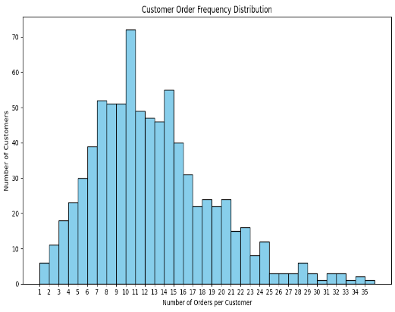
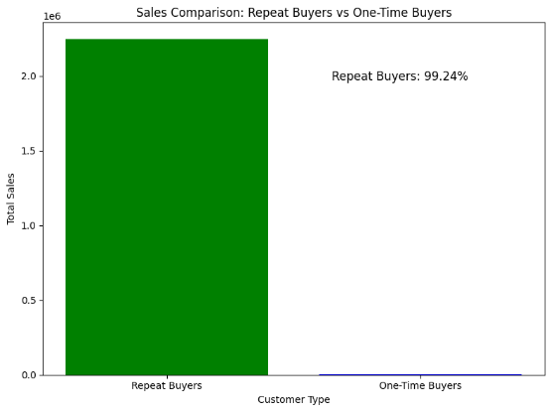
- Customer Order Frequency Distribution: The histogram shows that most customers have placed multiple orders, with some having exceptionally high order frequencies.

  - Analysis of segment and category of the product?
Objective: To analyse the sales distribution across customer segments and product categories. The goal is to identify which product categories (Furniture, Office Supplies, or Technology) generate the highest sales within each customer segment (Consumer, Corporate, Home Office, and Unknown).
Steps Taken
- Group the Data: Aggregate sales data by customer segment and product category using the groupby method.
- Pivot the Data: Create a pivot table with Segment as rows, Category as columns, and the total sales as values for better visualization.
- Plot the Data: Visualize the sales distribution using a bar plot to understand the contribution of each category within each segment.
Code Implementation:
- Grouping the Data:
- The groupby method aggregates the sales data by Segment and Category, producing total sales for each combination.
- This step provides the raw data for the pivot table.
- Pivot Table:
- The pivot table restructures the grouped data for easier interpretation.
- Rows represent customer segments, columns represent product categories, and values represent total sales.
- Visualization:
- The plot function creates a bar chart to visualize the relative contributions of each category within each segment.
- Non-stacked bars allow direct comparison of categories within the same segment.
Results:
- Consumer Segment: This segment generates the highest sales, with Technology leading, followed by Furniture and Office Supplies.
- Corporate Segment: Sales are relatively balanced across categories, with a slight preference for Technology.
- Home Office Segment: Technology products lead in sales, followed by Office Supplies and Furniture.
- Unknown Segment: Minimal sales in all categories, possibly due to incomplete customer data.
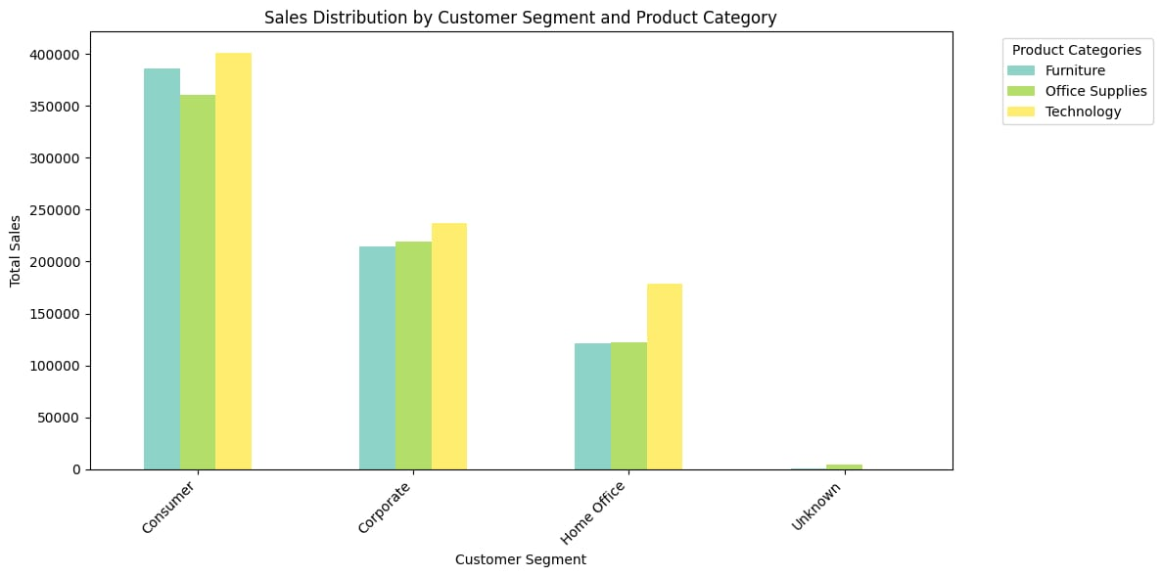

- Key Findings and Managerial Implications/Recommendations:
The Key insights drawn from the above analysis for each Research question and the Managerial Implications/Recommendations made from those Key insights are:
- What are the trends in total sales over time (monthly, quarterly, annually):
Key Insights:
- Volatility: Monthly and quarterly sales data exhibited significant fluctuations, with some months and quarters showing negative growth followed by periods of high growth. This may indicate seasonality or market-specific trends.
- Strong Recovery: Despite the fluctuations, the overall annual sales growth trend is positive, particularly in 2017 and 2018, suggesting a recovery or growth trajectory after a dip in 2016.
- Peak Sales Growth: March 2018 had the highest monthly growth rate, reaching nearly 200%, which could be an indicator of seasonal promotions or market expansion.
Implications:
- The fluctuating monthly and quarterly sales suggest a need for a more robust strategy to mitigate volatility, potentially due to seasonal or market-specific factors.
- The strong recovery in 2017 and 2018 shows that despite fluctuations, the company can bounce back. This could indicate that with proper management, growth is sustainable.
Recommendations:
- Leverage Seasonality: Analyze and anticipate the seasonal trends in sales to prepare targeted marketing campaigns or promotions during peak periods.
- Stabilize Quarterly Growth: Introduce strategies like customer loyalty programs or bundling during the low-growth months to smooth out the volatility.
- Focus on Long-Term Growth: Invest in initiatives that ensure consistent growth over the long term, similar to the recovery seen in 2017 and 2018, particularly after downturns in sales.
- Which product categories generate the highest revenue, and how do they compare to one another:
Key Insights:
- Dominance of Technology: The Technology category stands out as the highest revenue generator, contributing over a third of the total sales.
- Balanced Revenue Distribution: While Technology leads, Furniture and Office Supplies are relatively close in terms of their contributions to total revenue, both accounting for around 31-32%.
- Strategic Focus: Companies may want to focus on expanding the Technology product range, while also maintaining a strong presence in the Furniture and Office Supplies categories to ensure a diversified revenue stream.
Implications:
- The dominance of the Technology category in revenue generation indicates a strong market demand for tech products, while Furniture and Office Supplies are also important contributors.
- A balanced revenue distribution across categories (Technology, Furniture, Office Supplies) suggests that diversification of the product portfolio is crucial.
Recommendations:
- Expand Technology Offering: Given the high revenue contribution from Technology, the Superstore should consider expanding this product range, exploring emerging technologies, or introducing exclusive product lines.
- Strengthen Furniture and Office Supplies: While Technology is the leader, maintaining a strong presence in Furniture and Office Supplies is critical. The company should continue to innovate and differentiate these categories to ensure stable revenue streams.
- Product Bundling: Consider bundling products from different categories (e.g., Tech + Office Supplies) to increase average order value (AOV) and appeal to a wider customer base.
- How do sales vary across different regions and cities, and what factors may influence these differences:
Key Insights:
- Regional Sales Performance: The West and East regions generate the highest total sales, while the South region has the highest average sales per transaction.
- Sales Performance by Cities: Cities like New York City and Los Angeles dominate total sales, with smaller cities like Jamestown showing higher average sales per transaction.
- Influence of Shipping Time: The low correlation between shipping time and sales suggests that delays in shipping are not a significant factor influencing purchasing behavior. This could imply that factors like product demand, marketing, or customer preferences outweigh the impact of delivery times.
Implications:
- The West and East regions have the highest total sales, while the South region leads in average sales per transaction. This highlights the need for region-specific strategies.
- Certain cities like New York City and Los Angeles dominate in total sales, while smaller cities show higher average transaction values.
Recommendations:
- Regional Marketing Strategies: Tailor marketing campaigns and promotions for each region. For example, target larger regions (West, East) with mass-market campaigns while focusing on higher-value sales in the South through personalized offers.
- City-Specific Promotions: Leverage high-sales cities like New York and Los Angeles to test new product offerings or promotions that could be rolled out regionally. Conversely, focus on increasing transaction values in smaller cities with targeted upselling or cross-selling strategies.
- Investigate Market Potential in Smaller Cities: The higher average sales per transaction in smaller cities (e.g., Jamestown) indicates opportunities for growth. Focus on expanding presence in these markets through local partnerships or region-specific promotions.
- What is the relationship between customer segments and their purchasing behavior (average order value, frequency of purchases):
Key Insights:
- Higher AOV in Consumer Segment: The Consumer segment has the highest AOV, suggesting customers are willing to spend more per order. This segment may benefit from targeted marketing strategies aimed at increasing purchase frequency.
- Similar Purchase Frequency: Segments like Consumer and Corporate have high purchase frequencies, indicating strong customer loyalty and engagement.
- Lower AOV in Home Office and Unknown Segments: These segments show lower AOV, indicating a potential opportunity for upselling or cross-selling to increase the value of each transaction.
- Customer Engagement: The relatively high purchase frequency across segments suggests that many customers are repeat buyers, showing a good level of engagement with the brand.
Implications:
- The Consumer segment shows the highest average order value (AOV), indicating a willingness to spend more, while Corporate and Consumer segments exhibit strong purchase frequencies, suggesting high customer loyalty.
- The lower AOV in Home Office and Unknown segments presents opportunities for upselling or cross-selling.
Recommendations:
- Targeted Marketing for High AOV Segments: For the Consumer segment, implement loyalty programs and personalized marketing to increase purchase frequency and maximize the value of each transaction.
- Upselling and Cross-Selling: For the Home Office and Unknown segments, develop strategies to increase the AOV, such as offering discounts on complementary products or bundling low-value items with higher-value ones.
- Customer Retention Strategies: Given the high purchase frequency, continue building customer loyalty through regular communication, rewards programs, and exclusive offers to increase retention across all segments.
- Are there specific times of the year when sales peak, and how can this information be used for inventory management:
Key Insights:
- Sales Trends: Peak sales typically occur in the latter part of the year (November and December), with significant spikes in consumer purchasing behavior.
- Seasonality: The peaks in sales may be attributed to seasonal demand, holiday shopping, and end-of-year promotions.
- Inventory Management: Identifying the months with peak sales allows businesses to forecast demand and plan inventory accordingly.
Implications:
- Peak sales are seen towards the end of the year, particularly in November and December, driven by seasonal demand and holiday shopping.
- Understanding these trends can aid in managing inventory effectively and ensuring products are available during high-demand periods.
Recommendations:
- Optimize Inventory Management: Anticipate peak sales periods (November-December) and plan inventory accordingly. Avoid stockouts by increasing stock of popular items and use demand forecasting tools to predict needs.
- Seasonal Promotions: Plan marketing campaigns around these peak times with targeted promotions, discounts, or special offers to capitalize on holiday shopping trends.
- Offer Pre-Orders and Early Deals: Given the seasonal nature of peak sales, consider offering pre-orders or early bird discounts before the peak period to smooth out demand and reduce the strain on supply chains.
- Which Shipping Modes Are Most Popular Among Different Customer Segments?
Key Insights:
- Peak Sales Months Identified: The analysis revealed that sales peaked in September 2015, December 2016 and 2017, and November 2018. This suggests a seasonal trend with higher sales occurring in the latter part of the year.
- Consistent Year-End Demand: December stands out as a recurring high-sales month in 2016 and 2017, indicating a strong year-end demand, possibly driven by holiday shopping or end-of-year promotions.
- Variation in Peak Months: The shift from September (2015) to November (2018) as peak sales months suggests evolving consumer behavior or external factors influencing purchasing patterns.
Implications:
  - Seasonal Inventory Management: Inventory needs to be optimized for the latter months of the year, particularly November and December, to meet increased demand and prevent stockouts.
  - Sales Forecasting: The identified trends can be incorporated into sales forecasting models to predict future peaks and prepare accordingly.
  - Marketing Alignment: The timing of peak sales months provides insights for aligning marketing campaigns, promotions, and advertisements to maximize impact during these high-demand periods.
Recommendations:
- Stock Optimization:
  - Increase inventory levels in preparation for November and December, especially for high-demand products.
  - Coordinate with suppliers to ensure timely stock replenishment before peak months.
- Demand Analysis:
  - Analyze product-level trends to identify items driving peak sales and prioritize their availability.
  - Use historical sales data to refine inventory forecasts and identify potential new peak months.
- Promotional Strategies:
  - Design promotional campaigns targeting late-year consumers, leveraging historical data to maximize impact during peak months.
  - Explore early promotions in October to capture pre-holiday shoppers and smooth demand across months.
- Logistics Planning:
  - Ensure warehouse capacity and logistics capabilities are scaled to handle increased inventory and distribution during peak periods.
  - Develop contingency plans for potential supply chain disruptions in peak months.
- Are Certain Days of the Week or Times of Day Associated with Higher Sales Volumes?
Key Insights:
- Day-wise Sales Variation:
  - Saturday sees the highest sales, suggesting increased consumer activity during weekends.
  - Tuesday also exhibits strong sales, indicating potential mid-week shopping preferences.
  - Consistent Sales Early Week: Sales remain relatively steady from Monday to Wednesday, showing a consistent flow of customer activity during these days.
  - Low Sales on Thursdays and Fridays: Thursday has the lowest sales, followed closely by Friday, indicating potential gaps in customer engagement operational issues on these days.
  - Weekend Boost: A sharp increase in sales on Saturday aligns with typical weekend shopping behavior, possibly driven by consumer availability and leisure time.
Implications:
- Weekend Consumer Behavior: High sales on Saturday and consistent Sunday activity highlight the importance of capitalizing on weekend shopping trends.
- Opportunity for Mid-week Engagement: With Tuesday already performing well, strategic initiatives on other weekdays, especially Thursday and Friday, can bridge sales gaps.
- Operational Adjustments: Allocating resources (e.g., staff, inventory) in alignment with high-demand days like Saturday ensures customer satisfaction and operational efficiency.
Recommendations:
- Boost Weekday Sales: Launch promotional campaigns, discounts, or loyalty incentives targeting Thursday and Friday to increase customer activity during these low-performing days.
- Weekend Promotions: Maximize sales on Saturday by offering weekend-exclusive deals or flash sales, further encouraging consumer spending.
- Event-Based Campaigns: Plan mid-week events or campaigns to sustain the momentum observed on Tuesday and drive additional sales.
- Resource Allocation: Align staffing, marketing, and inventory strategies with sales patterns, ensuring high-performing days (e.g., Saturday) are well-supported to meet demand.
- What are the top-selling product categories within each region, and how can these insights be used to optimize inventory in different locations?
Key Insights:
- Technology Dominance: Technology is the leading product category in most regions, particularly in the Central, East, and South regions.
- Regional Variations: In the West, Furniture slightly outperforms Technology, indicating a regional preference.
- Steady Sales in Office Supplies: While not the top-performing category, Office Supplies shows consistent performance across all regions, contributing to steady revenue.
Implications:
- Technology Stock Priority: Higher demand for Technology products across most regions emphasizes the need to prioritize inventory allocation for this category in the Central, East, and South regions.
- Regional Strategy for Furniture: The West region's preference for Furniture suggests an opportunity to focus on Furniture promotions and inventory optimization in this region.
- Balanced Approach for Office Supplies: Office Supplies' steady performance indicates a stable but essential revenue stream, requiring adequate inventory levels across all regions to avoid disruptions.
Recommendations:
- Inventory Optimization for Technology:
- Increase Technology stock in Central, East, and South regions to meet higher demand and prevent stockouts.
- Implement forecasting tools to predict future demand more accurately for this category.
- Promote Furniture in the West: Design region-specific campaigns in the West to capitalize on Furniture's leading performance. Highlight exclusive deals or bundles to further boost sales.
- Maintain Steady Office Supplies Stock: Allocate sufficient stock of Office Supplies evenly across all regions, as it provides consistent sales and supports the overall revenue base.
- Localized Marketing Strategies: Use sales trends to craft regional marketing strategies. For example, emphasize Technology products in Central and East regions and Furniture in the West to align with regional preferences.
- Analysis of Customer Order Frequency?
Key Insights:
- High Customer Retention: A remarkable 99.24% of customers are repeat buyers, highlighting strong customer loyalty and satisfaction.
- Dominance of Repeat Buyers in Sales: Repeat buyers contribute $2,245,187.52 to total sales, significantly outperforming one-time buyers, who account for only $1,109.46 in sales.
- Order Frequency Distribution: The histogram reveals that most customers place multiple orders, with a small proportion of customers making exceptionally frequent purchases, possibly indicating high-value or loyal buyers.
Implications:
- Revenue Dependency on Repeat Buyers: The store's revenue heavily relies on repeat customers, emphasizing the need to maintain their loyalty through targeted engagement strategies.
- Opportunity to Convert One-Time Buyers: The minimal sales contribution from one-time buyers presents a potential growth opportunity by converting them into repeat customers.
- Segment High-Value Customers: Identifying and focusing on customers with exceptionally high order frequencies can yield significant revenue gains.
Recommendations:
- Loyalty Programs for Repeat Buyers: Design tiered loyalty programs to reward repeat buyers based on their purchase frequency, incentivizing further engagement and strengthening retention.
- Strategies to Engage One-Time Buyers: Implement personalized follow-up emails, first-time buyer discounts, and exclusive promotions to encourage repeat purchases from one-time buyers.
- Focus on High-Frequency Customers: Identify customers with exceptionally high order frequencies and offer them personalized incentives, such as VIP rewards, early access to products, or exclusive discounts.
- Monitor Trends in Order Frequency: Continuously analyse order frequency trends to adapt strategies and identify shifts in customer purchasing behaviour.
- Analysis of segment and category of the product?
Key Insights:
- High Customer Retention: A remarkable 99.24% of customers are repeat buyers, highlighting strong customer loyalty and satisfaction.
- Dominance of Repeat Buyers in Sales: Repeat buyers contribute $2,245,187.52 to total sales, significantly outperforming one-time buyers, who account for only $1,109.46 in sales.
- Order Frequency Distribution: The histogram reveals that most customers place multiple orders, with a small proportion of customers making exceptionally frequent purchases, possibly indicating high-value or loyal buyers.
Implications:
- Revenue Dependency on Repeat Buyers: The store's revenue heavily relies on repeat customers, emphasizing the need to maintain their loyalty through targeted engagement strategies.
- Opportunity to Convert One-Time Buyers: The minimal sales contribution from one-time buyers presents a potential growth opportunity by converting them into repeat customers.
- Segment High-Value Customers: Identifying and focusing on customers with exceptionally high order frequencies can yield significant revenue gains.
Recommendations:
- Enhance Technology Offerings for Consumers: Expand the range of Technology products and offer exclusive deals targeting the Consumer segment to capitalize on their preference.
- Cross-Selling in Corporate Segment: Promote bundled packages combining Furniture and Technology to encourage higher sales from the Corporate segment.
- Focus on Home Office Needs: Tailor marketing campaigns for Technology and Office Supplies products to meet the specific needs of Home Office customers. Consider introducing "home productivity" bundles.
- Address Data Gaps in Unknown Segment: Investigate and resolve missing data in the Unknown segment to better understand its sales potential and target untapped opportunities.
- Conclusion
This analysis highlights key insights that can drive strategic decisions for the Superstore. Sales data reveals volatility across months and quarters, suggesting the need for targeted promotions and seasonal planning to stabilize growth. Despite fluctuations, annual growth trends in 2017 and 2018 indicate a positive recovery, pointing to opportunities for strategic marketing around peak seasons.
The Technology category leads in revenue, but maintaining a diversified product portfolio with strong contributions from Furniture and Office Supplies is essential for balanced growth. Regional analysis shows that larger markets (West, East) should focus on broad campaigns, while smaller cities present opportunities for upselling.
Customer insights reveal higher AOV in the Consumer segment, highlighting potential for loyalty programs and targeted marketing, while Home Office and Unknown segments offer upselling opportunities. The Superstore should also capitalize on seasonal peaks by optimizing inventory management during high-demand periods, particularly in November and December.
In summary, by aligning strategies with these insights—focusing on product diversification, regional customization, and customer engagement—the Superstore can strengthen its market position and drive both short-term growth and long-term customer loyalty.

- Explanation of Functions Used in the Analysis
In this section, we explain the specific functions utilized in the analysis and why they were chosen. These functions were selected for their efficiency, clarity, and ability to address the particular needs of our project. Below is a detailed explanation of the functions used for key tasks in our analysis.
  - Using idxmax() function for Peak Sales Identification: The idxmax() function was chosen to identify the months with the highest sales in each year because it returns the index (or timestamp) of the maximum value in a given series. In time series analysis, the goal is often to find key dates or periods (such as peak sales months), and idxmax() allows us to directly locate the exact time point (month, day, etc.) when the highest sales occurred. Other functions, like max() or nlargest(), could give the maximum value or the top values, but they wouldn't directly return the index, making them less suitable for tasks that require pinpointing exact dates or periods associated with peak values.
  - Using corr() function for Correlation Analysis: The corr() function was used to assess the correlation between sales and other numerical columns, such as Days_Difference. This function calculates Pearson’s correlation coefficient, which measures the strength and direction of the linear relationship between two variables. It's the most straightforward and widely used method for identifying correlations in time series or tabular data where the relationship between numerical variables is of interest. Other functions like cov() (for covariance) could be used, but correlation standardizes the relationship and provides a clearer, more interpretable measure of the strength and direction of the relationship between variables (in this case, sales and shipping times).
  - Using combine_first() function for Updating Customer Names: The combine_first() function was chosen for updating missing values in the Customer_Name column by filling null entries with corresponding values from another DataFrame. This function is ideal for this use case because it fills missing values in one DataFrame with values from another DataFrame based on matching indices. It's efficient for situations where we need to combine information from two sources, ensuring that missing or null values are filled with available, relevant data. Other functions, such as fillna(), could also be used to handle missing values, but combine_first() is more appropriate when the missing data in one DataFrame should be replaced by non-null values from another DataFrame, especially when they share the same index structure. Functions like merge() or join() are more complex and generally used for combining entire DataFrames, not specifically for filling missing values with another DataFrame's data.

- Appendix
  - The Juypter Notebook file named ‘PLBA_Project_file_final’ uploaded in assignments.

- References
- The direct link to the dataset is: https://www.kaggle.com/datasets/bhanupratapbiswas/superstore-sales/data
- The link for the reference for using ‘idxmax()’ function for time series analysis: https://pandas.pydata.org/docs/reference/api/pandas.DataFrame.idxmax.html
- The link for the reference for using ‘corr()’ function for finding the relation between different columns: https://www.w3schools.com/python/pandas/pandas_correlations.asp
- The link for the reference for using ‘combine_first()’ function for Combine two DataFrame objects by filling null values in one DataFrame with non-null values from other DataFrame: https://pandas.pydata.org/docs/reference/api/pandas.DataFrame.combine_first.html

